UNIT 1 : A VISIT FROM A PEN PAL
PERIOD 5: READ
A/ Warm up:
How can you call the units of currency of each country below?

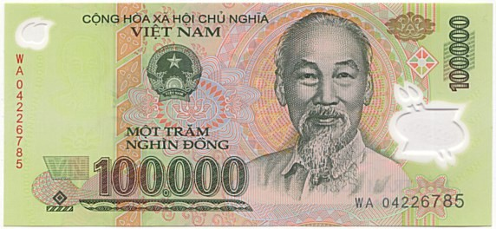
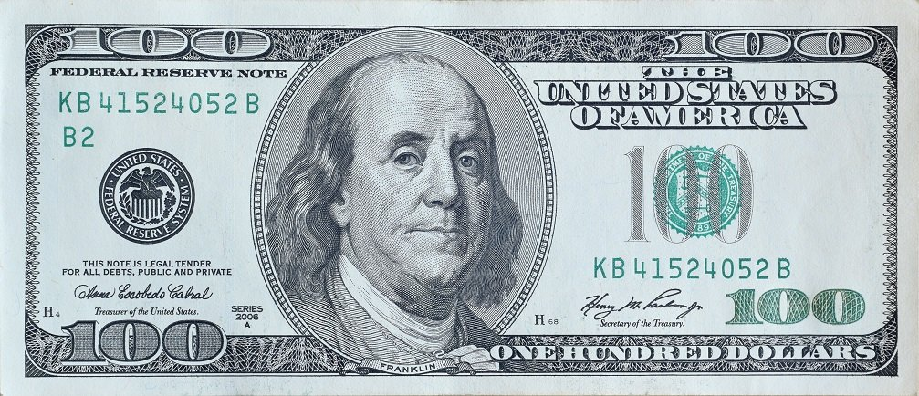

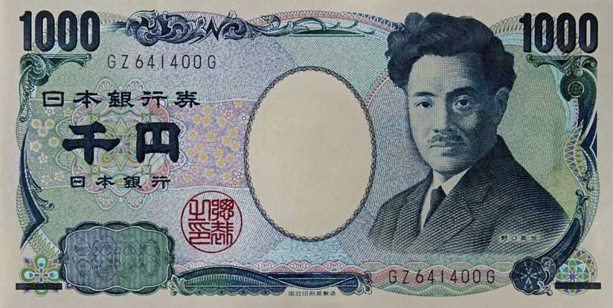
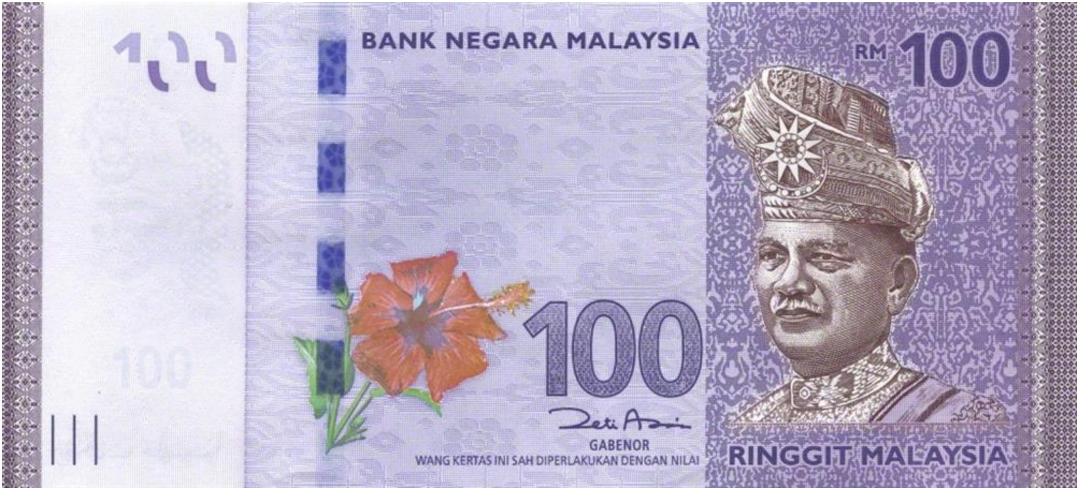

* Unit of currency: The money that is used in a particular country.
B/ Presentation:
How much do you know about Viet Nam? Let’s explore these fun facts together:
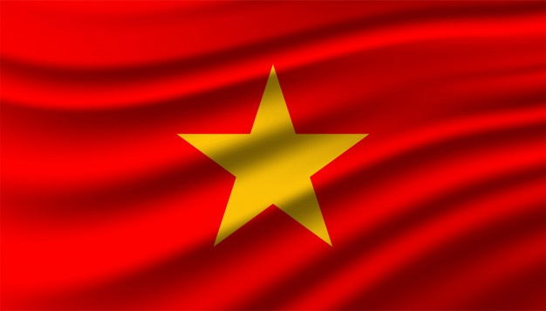

1. Viet Nam is one of the members of ASEAN.
- ASEAN: The Association of South East Asian Nations
2. Viet Nam has the area of 331, 212 sq km.
- Area (n) /ˈeəriə/: the measure of a flat space or surface:
3. The population in Viet Nam is around 96,46 million.
- Population (n) /ˌpɒpjʊˈleɪʃ(ə)n/: the number of people living in a particular country, area, or town.
4. Our primary language of instruction is Vietnamese.
- Primary language = first language
5. Vietnam's major religions are Buddhism and Catholicism
- A religion (n) /rəˈlijən/ a particular system of faith and worship.
6. Viet Nam has a tropical climate.
- Climate (n) /ˈklaɪmət/ the general weather conditions

7. Students in secondary school study English as a compulsory second language.
- Compulsory (adj) /kəmˈpʌlsəri/ : if something is compulsory, you must do it because of a law or rule
≠ Optional (adj) /ˈɒpʃ(ə)nəl/
8. Divide (v) /dɪˈvaɪd/: to separate into parts or groups.
9. Instruct (v) /ɪnˈstrʌkt/ to teach someone how to do something
VOCALBULARY ( ghi vào tập)
1. ASEAN (the Association of South East Asian Nations) | n |  | Hiệp hội các quốc gia Đông Nam Á
2. Area | n | /ˈeəriə/ | Diện tích
3. Population | n | /ˌpɒpjʊˈleɪʃ(ə)n/ | Dân số
4. Primary language  = First language | n | /ˈpraɪməri/ | Ngôn ngữ chính thống, tiếng mẹ đẻ
5. Religion | n | /rəˈlijən/ | Tôn giáo
6. Climate | n | /ˈklaɪmət/ | Khí hậu
7. Compulsory  ≠ Optional | adj | /kəmˈpʌlsəri/  /ˈɒpʃ(ə)nəl/ | Bắt buộc  ≠ Tự chọn (không bắt buộc)
8. Divide | v | /dɪˈvaɪd/ | Chia ra, phân tách
9. Instruct | v | /ɪnˈstrʌkt/ | Hướng dẫn, dạy học
C/ Practice
Task 1:
Look at the table. Listen to the tape and mark (X) if the numbers given are True or False . You can note down what you hear.
 |  | 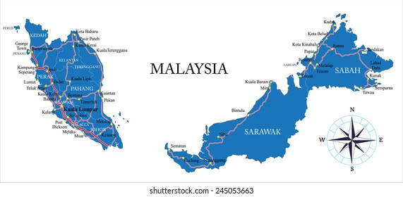

Anthem
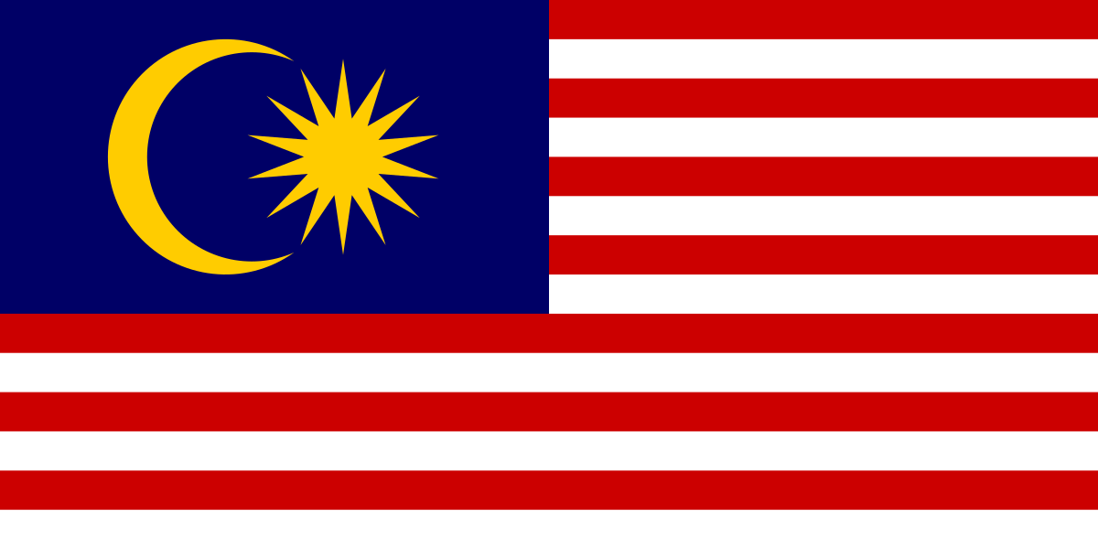
Title | Figures | True | False | Note
1. Distance separated by the sea | 640 km
2. Area | 325, 758 sq km
3. Population in 2001 | Over 31 million
4. Religions | More than 2
5. Language | Only 1
Task 2: Read the text carefully then fill in the table with the right information about Malaysia.
Malaysia is one of the countries of the Association of South East Asian Nations (ASEAN). It is divided into two regions, known as West Malaysia and East Malaysia. They are separated by about 640 km of the sea and together comprise an area of 329,758 sq km. Malaysia enjoys tropical climate. The Malaysian unit of currency is the ringgit, consisting of 100 sen.
The capital of Malaysia is Kuala Lumpur and it is also the largest city in the country. The population in 2001 was over 22 million. Islam is the country’s official religion. In addition, there are other religions such as Buddhism and Hinduism. The national language is Bahasa Malaysia (also known simply as Malay). English, Chinese, and Tamil are also widely spoken. The language of instruction for primary school children is Bahasa Malaysia, Chinese, or Tamil. Bahasa Malaysia is the primary language of instruction in all secondary schools, although some students may continue learning in Chinese or Tamil. And English is a compulsory second language.
(ghi vào tập)
1. Area:................................................ 5. Capital city: ....................................................
2. Population: ...................................... 6. Official religion: .............................................
3. Climate: ........................................... 7. National Language: ........................................
4. Unit of currency: ............................. 8. Compulsory second language
......................................................................

Task 3: True or False? Check (X) the boxes. Then correct the false statements. ( ghi vào tập)
 | T | F
1. Malaysia is a member country of ASEAN. | x
2. Hinduism is the official religion in Malaysia.
......................................................................................
3. People speak only Malay in Malaysia.
.........................................................................................
4. Primary school children learn three languages at school.
...........................................................................................
5. All secondary school children learn in English.
...........................................................................................

Task 4: Fill in the blank to complete the summary: ( ghi vào tập)
Malaysia, which is one of the countries of ASEAN, enjoys tropical climate. It’s (1) __________ into two (2) __________, known as West amd East Malaysia. They are (3) _______by the sea and (4) ________ an area of 329, 785 sq km. The Malaysian unit of (5)________ is ringgit. Beside Islam, there exists other (6) ___________ such as Buddhism and Hinduism. Bahasa Malaysia is the (7)___________ language of instruction in all secondary school and English is a (8) ___________ second language.
Task 5: Mini game: Sharp Eyes
Identify the mistakes and correct them in 20s. (you can underline or highlight the mistakes)
1. Islam is the unofficial religion of Malaysia. ______________
2. There are other regions such as Buddhism and Hinduism. ______________
3. English is an optional second language in secondary school in Viet Nam. _______________
4. South America divided from Africa 200 million years ago. __________________
5. Chinese and Tamil are also wide spoken in Malaysia. ___________________
Task 6: Quick reaction:
Teacher will read the questions and students have to give the correct answers as soon as possible:
1. What is the national language in Malaysia?
2. Is Bangkok the capital city of Malaysia?
3. The Malaysian currency doesn’t consist of 100 sen. True or False?
4. Is English used as the language of instruction for primary school children in Malaysia?
5. What are three languages that children learn at primary school .
* REMINDER: Don’t forget to study more about our beloved country as well.

